- Create a simple cloud software application for Flight Reservation System using any Cloud Service Provider to demonstrate SaaS.

Aim:

To create a simple cloud-based Library Book Reservation System for SIMATS Library using a Cloud Service Provider and demonstrate SaaS.

Procedure:
Log in to a cloud service platform.
Create a web application for library book reservation.
Design forms for book search and reservation.
Store book and user details in a cloud database.
Deploy the application on the cloud.
Access the application through the internet.
Flow chart:
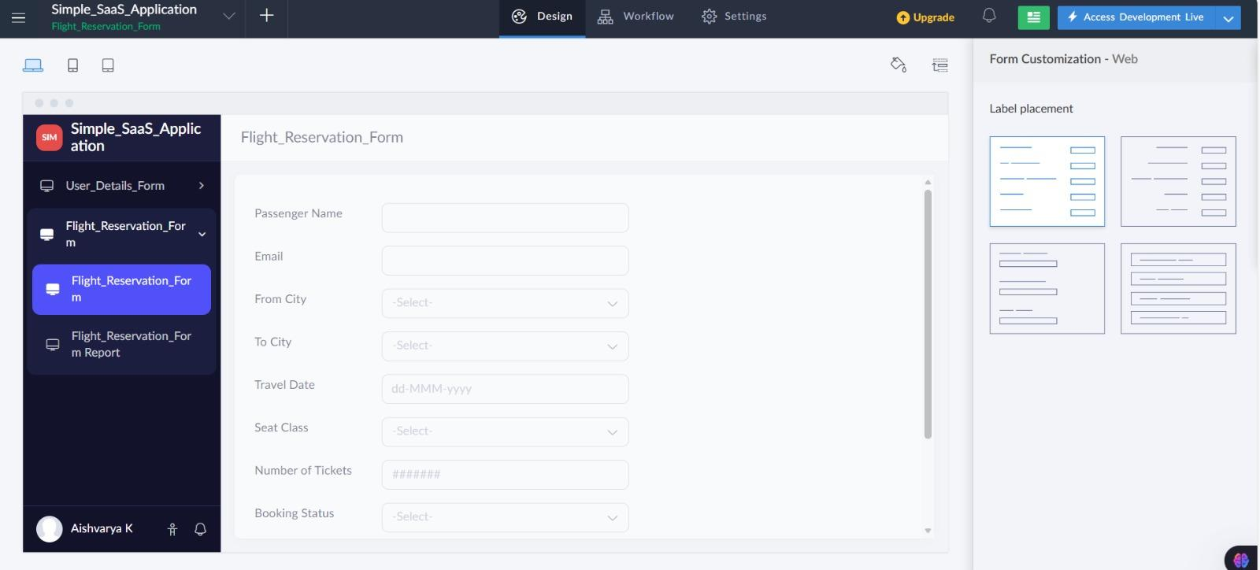
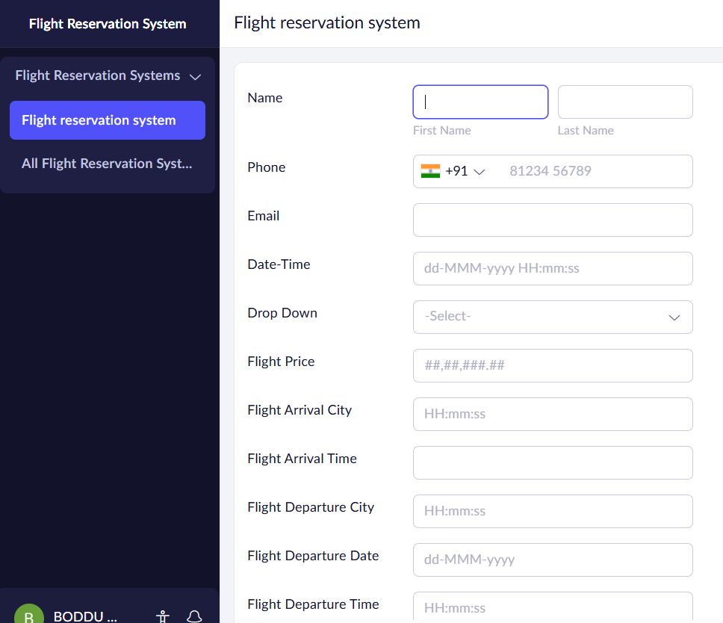

Result
A cloud-based Library Book Reservation System for SIMATS Library was successfully developed and deployed, demonstrating the SaaS model.

